Year 10

Test 3

Measurement

2019


Name: ______________________ Class: ______ Time: 35 minutes Total Mark:____/28

Show working and answers on this sheet. Show working in sufficient detail to support your answers. Incorrect answers without supporting reasoning will be allocated zero marks.

Resources: 1 A4 page of notes (2 sided),Yr 10 formula sheet, Calculator.

Surface Area

Question 1 2, 3, -5 marks

Determine the surface area of the following 3D Shapes:
a)

b)

Question 2 5 marks

Calculate the surface area of the following composite solids
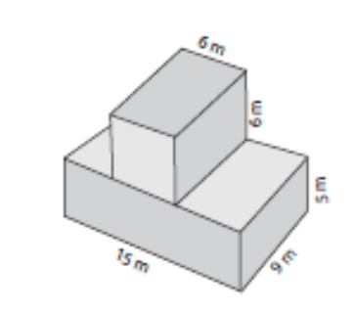
a)

Question 3 3 marks

Calculate the surface area of a cylinder (with closed ends) with diameter of 15 cm and a height of 26 cm.
(HINT: Draw a diagram and use the formula if needed)

Question 4 4 marks

Calculate the surface area of the following triangular prism

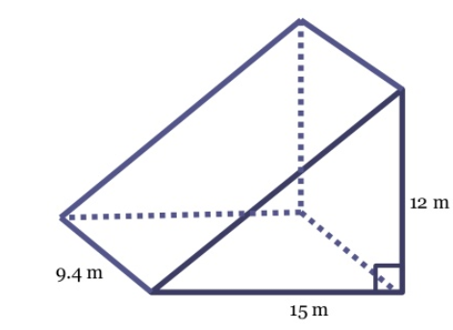

Volume

Question 5 6 marks

Calculate the Volume of the following 3D Shapes.
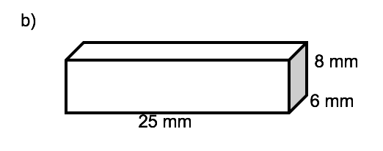
a)

b)
c)
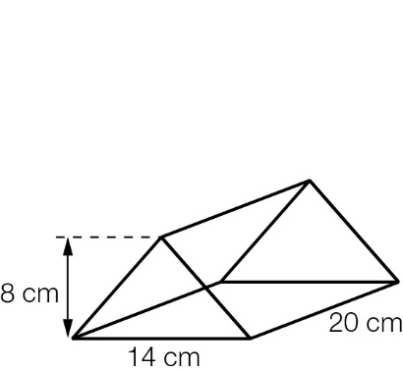

Question 6 3 marks

Calculate the volume of the following solid

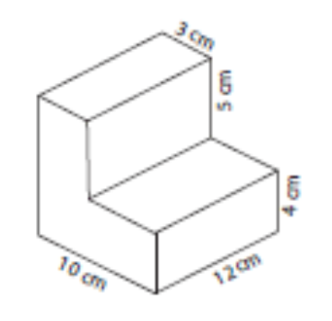

Question 7 2 marks

A cylinder has a volume of 375 cm³ and a height of 15cm, find its radius.

END OF TEST

